**Safety System**

**Research Analysis**

**Vehicle Dynamics Department**

**University of Salford Race Team**

**Introduction**

This report covers the safety precautions which must be taken for the driver and the team during static and dynamic tests. The report also covers the risk assessment which must be taken for the safety given by the rules from iMeche 2018.

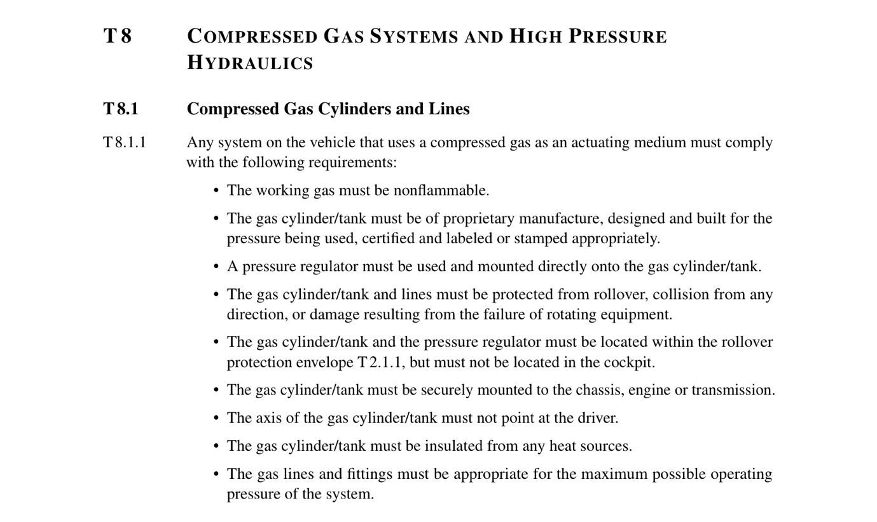**Rules**

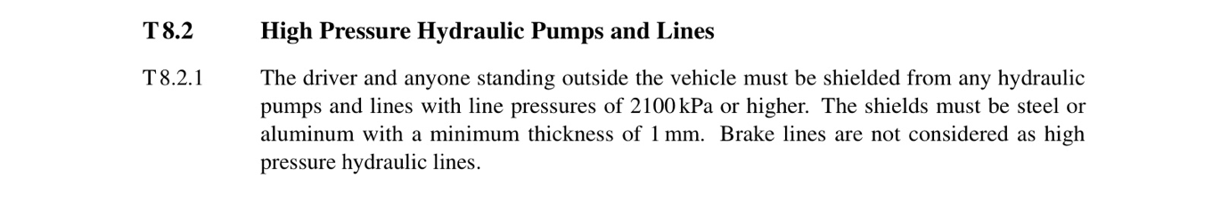

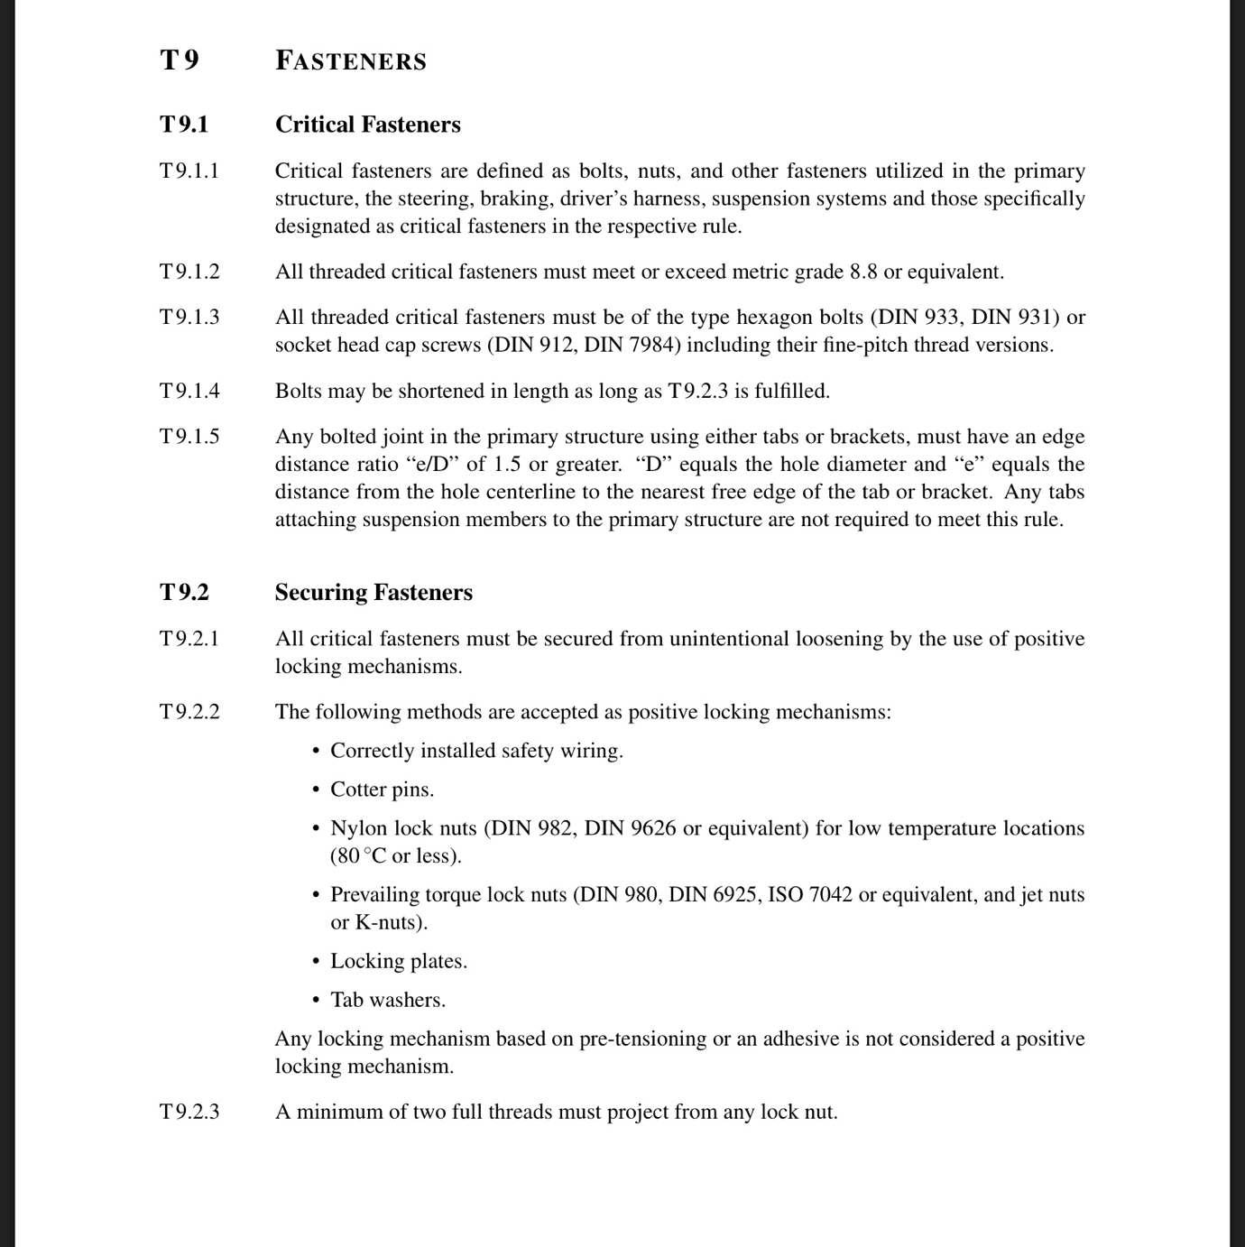

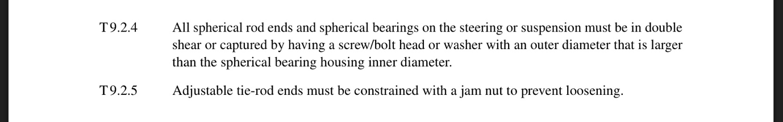

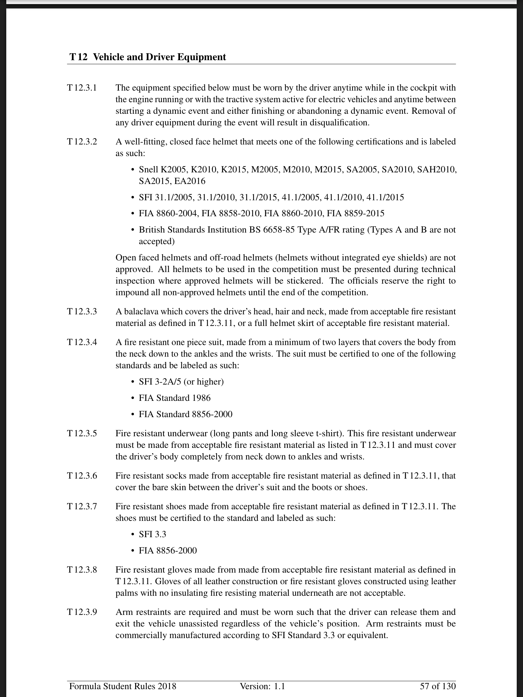

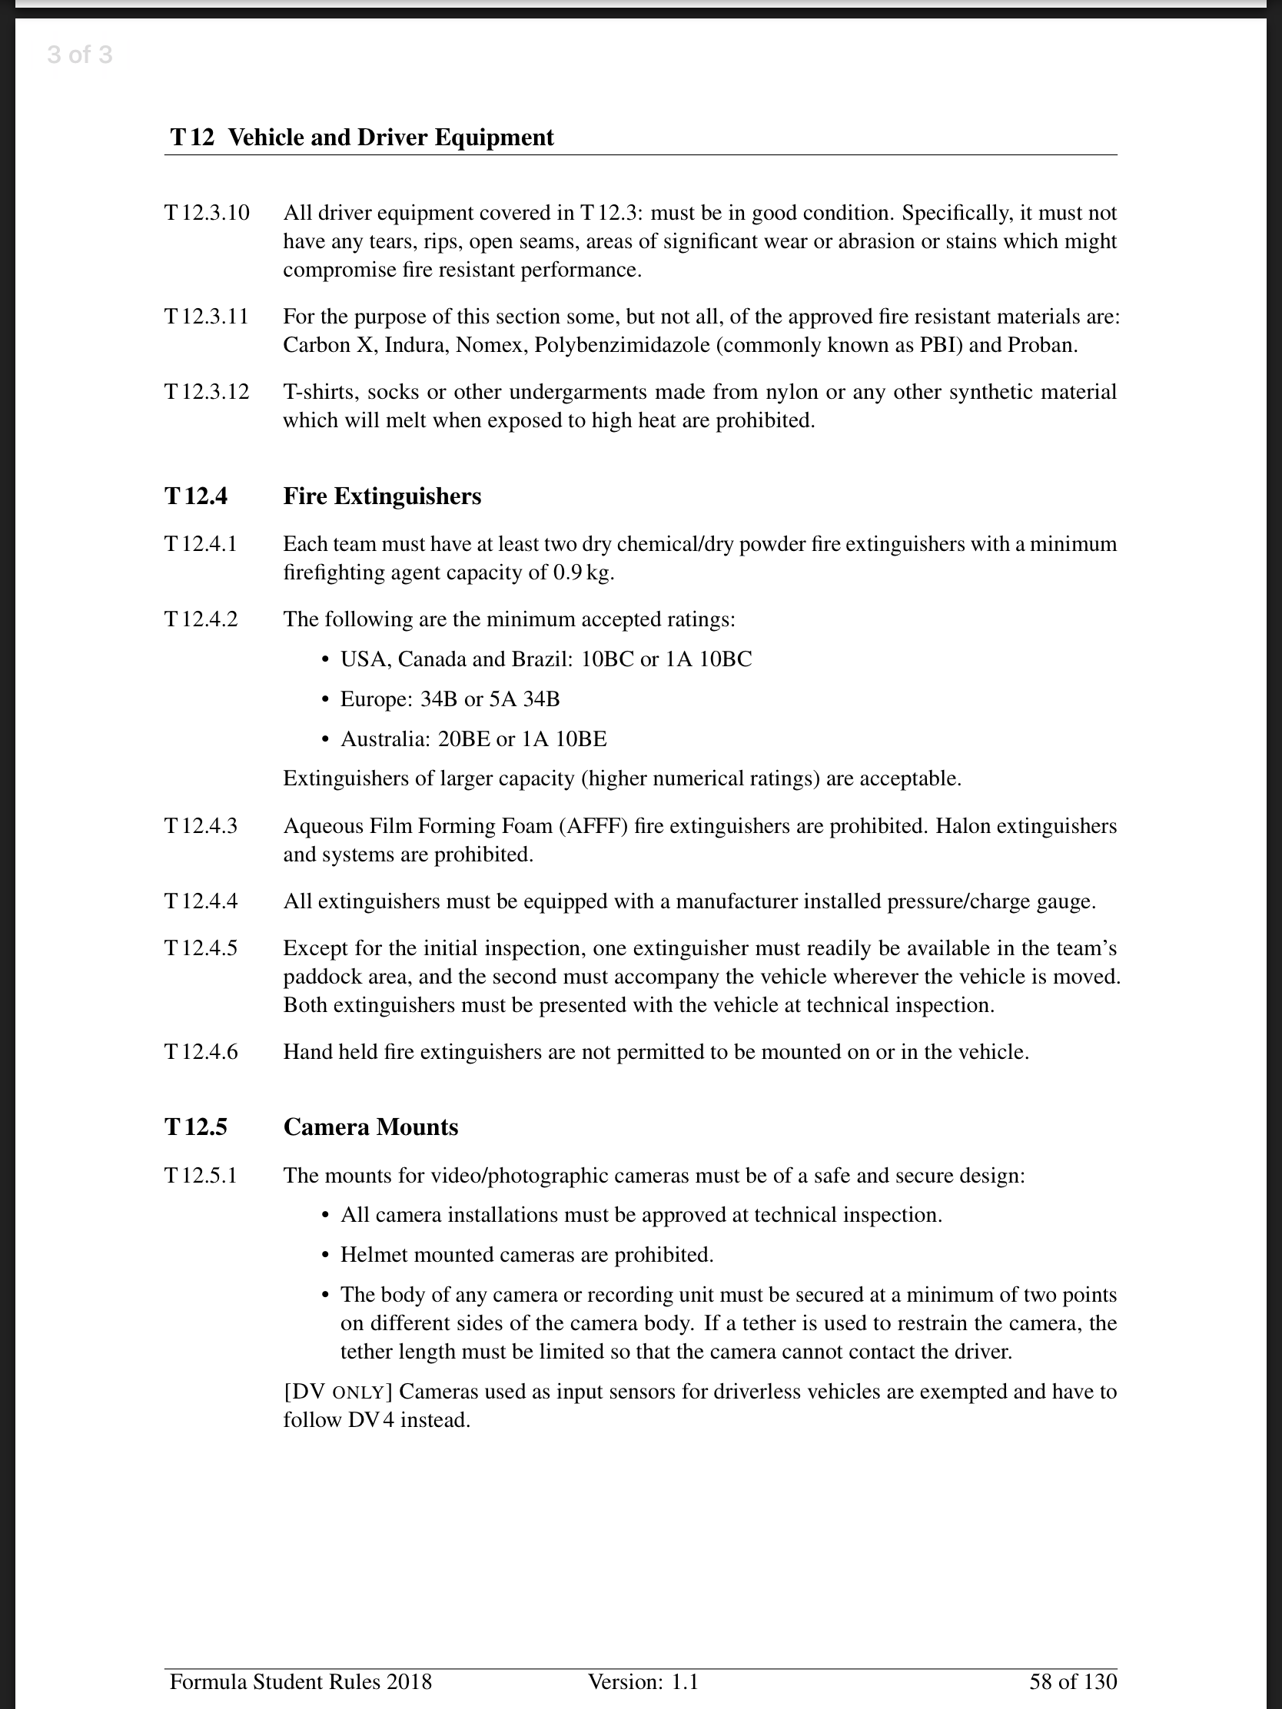

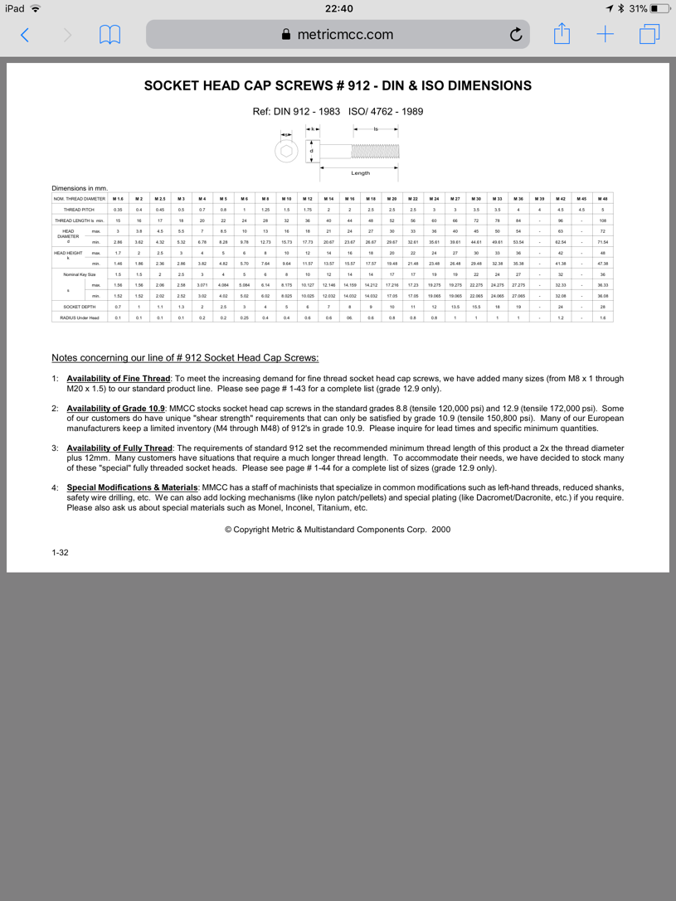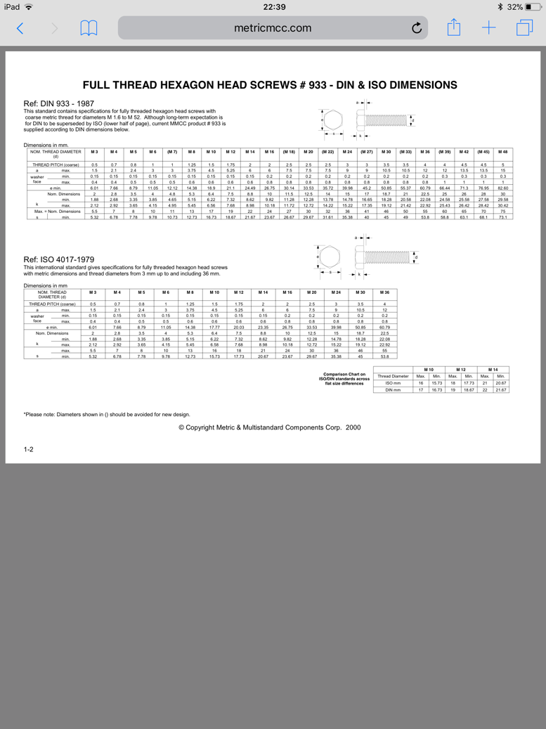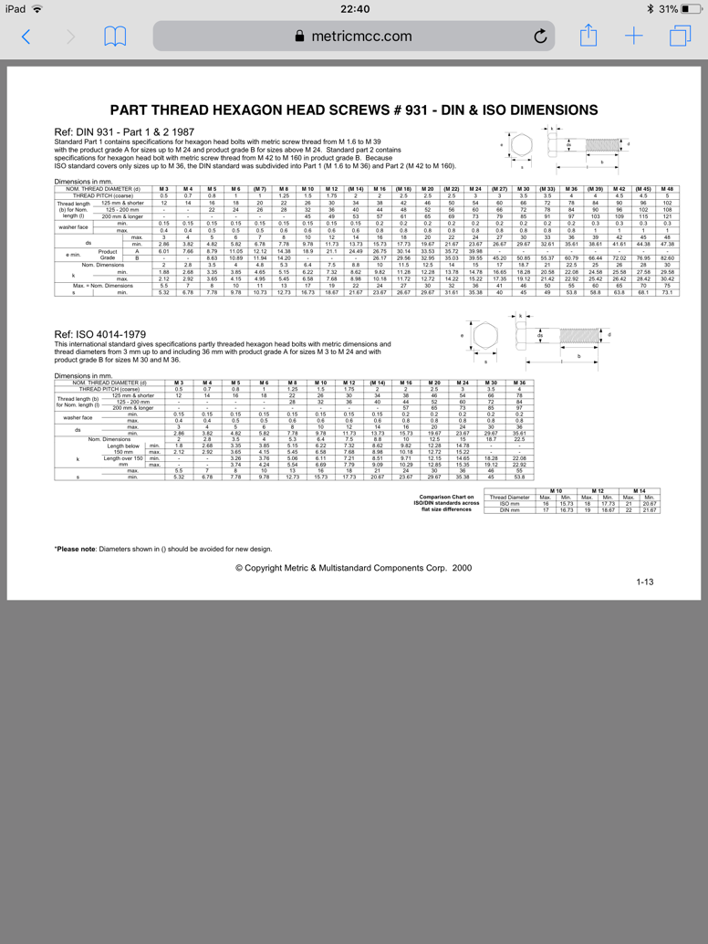**Fastener**

**Helmet**

**Circuit Racing**

If you are circuit racing in either single seaters or saloon cars the type of helmet that you need to be looking for is more of a straightforward choice. Let’s focus on single seaters first. Every driver who is planning to race a single seater must wear a full face helmet. There is one exception to this rule in the form of historic single seaters where it is possible to wear an open face helmet with goggles, as it was in period. In this case, it is best to clarify with your series organiser. For all other, non-historic, single seater championships a full face helmet is required and it is recommended to wear a helmet which has a narrow aperture, the height of the visor, as to limit the possible impact of debris to the visor area.

In saloon, or closed roof, circuit racing the choice of helmet type is less constrained meaning that the driver can wear either a full face or an open face helmet depending on personal preferences and fit.

**FHR** **&** **HANS** **devices**

When competing in motorsport, safety for the driver or co-driver is paramount. Hence why in 2016 the MSA made the use of an FHR device mandatory for all circuit racing, stage rallying, hill climbs and sprints. FHR stands for Frontal Head Restraint and they are designed to protect the neck in the event of an accident by reducing the speed and the distance that it is thrown forward by the impact. FHR devices are typically available in a selection of fixed recline angles to suit various seating positions as found in saloon, or single seater racing cars. The most common recline angle is 20 degrees, is mostly found in saloon cars where the driver sits reasonably upright in the car. Also available are 30 and 40 degree angles to suit single-seater and sports prototypes with the latter angle for more extreme applications such as Formula 1 type single seaters. There are, however, types of FHR device which are not angle specific such as an adjustable HANS type device as well as the Hybrid FHR devices which are not limited to a certain recline angle but also offer a degree of lateral protection.

FHR is a device that restricts the forward motion of the user’s head and extension of the neck during periods of rapid forward deceleration. The restriction of this motion dramatically reduces the risk of neck injuries which is why the FIA and MSA have now made FHR devices mandatory for the majority of motorsport classes.

**How does it work?**  
There are a number of different products homologated by the FIA as FHRs. The most common device is the ‘HANS’ where a yoke is secured on the wearer’s shoulders by the pressure of the safety harness shoulder straps. Straps connect the wearer’s helmet to the vertical upstand integral in the yoke. The length of the tethers limits forward motion of the head relative to the body. An alternative device uses tet hers to attach the helmet to a ‘waistcoat’ worn by the user, an example of which is the Simpson Hybrid.

**FHR Attachments for helmets**.  
Helmets which are to be used with a FHR device are required to have receptacles, known as clips or posts, attached to the helmet. All helmets which carry the Snell 2010 or above certification have the provision for the clips which can easily be retro fitted by the wearer and are approved by the FIA.

Top of Form

Bottom of Form

|  |  |  |
| --- | --- | --- |
|  | **PRICE** | £199.95 + VAT |
| **CERTIFICATION** | Snell SA2015 |
| **OTHER** | HANS compatible  Removable Fire Retardant Lining |
| **LINK** | https://www.demon-tweeks.co.uk/motorsport/helmets/race-safety-accessories-pro-full-face-helmet |
|  | **PRICE** | £405.34 + VAT |
| **CERTIFICATION** | Snell SA2015  FIA 8859-2015 |
| **OTHER** | Removable Lining  High Level Of Ventilation |
| **LINK** | https://www.demon-tweeks.co.uk/motorsport/helmets/sparco-air-pro-rf-5w-helmet-matt-black |
|  | **PRICE** | £423.00 + VAT |
| **CERTIFICATION** | Snell SA2015  FIA 8859-2015 |
| **OTHER** | Lightweight  Professional Circuit Use |
| **LINK** | https://www.demon-tweeks.co.uk/motorsport/helmets/stilo-st5f-n-composite-helmet |
|  | **PRICE** | £434.10 + VAT |
| **CERTIFICATION** | FIA 8859-2015 |
| **OTHER** | Lightweight  Available with FHR Posts |
| **LINK** | https://www.demon-tweeks.co.uk/motorsport/helmets/bell-gp3-sport-helmet-matt-black |

**Race Suits**

A race suit is the first line of protection for a driver when faced with a fire. Constructed from multiple layers of fire retardant material. The suits come in single, double or triple layer and we will be considering the double layered or triple layered. Some suits such as OMP provide a ‘Dry System’ which helps drivers reduce body temperature and improve performance. This reduces the risk of hypothermia, risk of accidents and reduces fatigue resulting in greater performance.

**Fire Extinguishers**

Fire extinguishers can be found in range of sizes and are available as a set (handheld and plumbed) or individually.

**Dry Chemical**

**Dry Chemical**fire extinguishers extinguish the fire primarily by interrupting the **chemical reaction**of the fire triangle.

Today's most widely used type of fire extinguisher is the multipurpose dry chemical that is effective on Class A, B, and C fires. This agent also works by creating a barrier between the **oxygen**element and the **fuel** element on Class A fires. Ordinary dry chemical is for Class B & C fires only. It is important to use the correct extinguisher for the type of fuel! Using the incorrect agent can allow the fire to re-ignite after apparently being extinguished successfully.

**Dry Powder**

**Dry Powder** extinguishers are similar to dry chemical except that they extinguish the fire by separating the **fuel** from the **oxygen** element or by removing the **heat** element of the fire triangle. However, dry powder extinguishers are for Class D or combustible metal fires, only. They are ineffective on all other classes of fires.